**Date:**  30/04/2022

**Program-09**

**AIM:** Write a program to generate a Fibonacci series using Copy Constructor. **CODE:**

#include <iostream>

using namespace std;

class fibonacci{

int a,b;

public:

fibonacci(){

a=0;

b=1;

}

fibonacci(fibonacci &prev) {

b=prev.a+prev.b;

a=prev.b;

}

void getA(){

cout<<a<<endl;

}

};

int main(){

fibonacci f1;

int n;

cout<<"Enter value till which you want to get fibonacci series?";

cin>>n;

if(n>0)

f1.getA();

for(int i=0;i<n-1;i++){

fibonacci f=f1;

f.getA();

f1=f;

}

return 0;

}

**OUTPUT:**

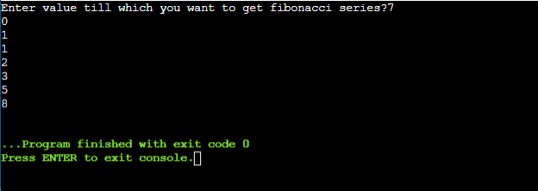

**Date:** 30/04/2022

**Program -10**

**AIM:** Create a class which keep track of number of its instances. Use static data member,

constructors and destructors to maintain updated information about active objects.

**CODE:**#include <iostream>  
  
using namespace std;  
class countobj{  
    static int count;  
    public:  
        countobj(){  
            cout<<"The number of objects created are:"<< ++count << "\n";  
        }  
        ~countobj(){  
            cout<<"The number of objects remaining are:"<< --count << "\n";  
        }  
};  
int countobj :: count = 0;  
int main()  
{  
    countobj o1, o2, o3;  
  
    return 0;  
} **OUTPUT:**

